Title: Text Analytical tools for business purposes
Name:
Course Number:
Course name:
School affiliations:
Professor’s name:
Date:

Introduction
Most organizations have an enormous measure of text based information, for example, notices, organization archives, messages, reports, media discharges, client records and correspondence, sites, websites and web-based social networking posts. In any case, that has all changed because of text analysis. Text analysis, or text mining, is a procedure of extracting valuable information from expansive amounts of unstructured text information. While the text itself is organized to sound good to an individual (i.e., an organization report can be split into sensible segments), it is unstructured from an examination point of view since it doesn't fit flawlessly into a social database or the lines and sections of a spreadsheet. Customarily, the main organized piece of Text was the name of the report, the date it was made, and who made it.
Business of interest
My business of interest is a chain a chain of stores that deals with household items such as cereals. This is a competitive business with most of the companies in the industry being well established such as Walmart. Other companies who have interest in the cereal market include Coca Cola and Pepsi. Products that I am interested in include oats and other cereals. The interest for oats is constantly high. Regardless of whether it's the dry or rainy season, individuals need to eat and oats give a shabby and nutritious alternative. This business has turned out to be extremely productive throughout the years. Other than oats I purpose to offer; rice, beans, groundnuts, green grams, maize, wheat, sorghum among others.
Negative/ positive reviews
Text investigation enables the business to evaluate all that free-streaming unstructured text and build up patterns or groups of sentiment in the business, divisions, and inside particular groups. For instance, the business just sweeps and breaks down the substance of messages sent by the staff and also their representatives' media posts on Facebook or Twitter. This enables the business to comprehend the levels of staff engagement without the time and cost of a customary review. The utilization of World cloud generator in the business is likewise having a major effect on the activities of the business, for example business surveys. This has helped Walmart to carry out survey and improve on business performance among other benefits.
The negative part to utilize Word cloud generator for a business such as Walmart is that it is changing over more seasoned, paper-based text records into something that can be utilized for business analysis and this can be extremely tedious and costly. Additionally remember that most information has a timeframe of realistic usability. As opposed to changing over old text into an analysis-ready format, it is regularly better to concentrate on the new text data for the business, for example, messages and online networking posts.
How does the focal business compare with its competitors
As worldwide demands for cereals develops for American-style breakfast sustenance, cereal advertisers are doing what they can to settle on their brands as the best choices globally. The competition is savage among Walmart, Kellogg, PepsiCo and Cereal Partners Worldwide, a joint wander between General Mills and Nestle. Together these mammoths control over 50% of the almost $30 billion overall hot-and frosty grain advertise, as per Euromonitor International. In spite of the competition, my business of interest (Walmart) appears to have a shot in the market on account of the open doors which are emerging among the shoppers over the globe. In any case, even as grain producers use their immense worldwide promoting spending plans to goad development, they are finding that breakfast is still affected by nearby traditions. In reality, the hardest rivalry may be from breakfast nourishments.
Proposed idea to use Word cloud generator
Word cloud generator gives the business exceptionally valuable data in various regions. The utilization of the program isn't restricted to;
1. Parse worker or client criticism.
What was the greatest point on clients' psyches as they finished your overview? What words did representatives utilize frequently in their assessments? What was inclining in a month ago's online client remarks? On the off chance that the business approaches information sources, it's a simple assignment to join them into a text record, drop the duplicate into a generator and see what develops. Survey the subsequent cloud in order to examine what high events of words like "responsiveness" or "cost" may show. The business should keep in mind that cloud take words outside the realm of context, so a major, strong "Administration" in the cloud could be "amazing."
2. Check the adequacy of the business’ composed correspondences.
What does your pamphlet truly say? What does your web text concentrate on? What words or terms do the business depend on too intensely? Dropping a couple of pages of substance into a Word cloud generator is an extraordinary approach to check repeating subjects or terms and to enhance the businesses’ written work—both as far as style and clarity.
3. Enable individuals to adjust around business’ central goal and vision
How would the business influence its association's with the main goal or vision explanations to become animated for workers and partners? How would the business enable groups to line up with the mission or vision and take responsibility for the same? Here's an activity called "Stick the Tale on the Mission." It's helpful for the business to get groups inside the association of the staff, board individuals, volunteers, initiative, advocates to investigate their own associations with the association's central goal or vision.
How to enter data (e.g. removing stopwords)
Stage 1: Install R.
Got to r-project.org and take after the download/establishment directions. Simple.
Stage 2: Install RStudio.
Why? Since it makes R significantly more usable. RStudio is an open-source UI arranging all that is required on one single screen. There are convenient tabs and windows: charge line, workspace, history, documents, plots, bundles and help .
Stage 3: Create a Text document to transform into a wordle
You can utilize any Text you like for the business. Copy and glue the text into a plain text record (e.g. lords.txt) and stick the record into a committed index in your default archives envelope. Ensure there are no different documents in this catalog.
Stage 4: Open RStudio, introduce required or missing bundles
For this activity you require the Text mining bundle ('tm') and the wordcloud bundle ('wordcloud'). Thus, each of those make utilization of different bundles as well. Tap on the Packages tab (base right window in RStudio) and check whether they're recorded. If not, go to Tools > Install Packages (top menu bar) and introduce them from that point. As opposed to mess around physically with downloaded compress documents, just introduce the bundles straight through the default CRAN reflect alternative (in the event that you have a firewall, ensure the URL isn't blocked). Once introduced, tick the required in the rundown under the Packages tab – this will basically stack and actuate them in the workspace (it's the same as utilizing the 'library' order in R). As you tick them, you may get a few notices of further missing bundles that they depend on assuming this is the case, introduce those bundles as well.
Stage 5: The information procedure – Text mining, tidy up, wordcloud, stopwords, e.t.c
Presently we have to stack the Text record into RStudio and tidy it up with the goal that the word cloud bodes well (for instance, you would prefer not to feature regular words like 'the'). For reference see Introduction to the tm (Text mining) Package. To begin with, you have to stack the Text into a supposed corpus, so the tm bundle can process it. A corpus is a gathering of reports (in spite of the fact that for our situation we just have one). The accompanying order loads everything (be careful!) from the predetermined registry (recall that, I called it 'temp') into a corpus called 'rulers':
How the program should display the word clouds
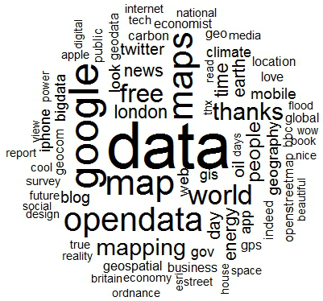

Ways to use the program (Word cloud generator) e.g. understand what people
1. SEO Analysis. A word cloud is a superb approach to check that you are utilizing the right catchphrases and for finding new watchwords. Run your blog, website page, even your official statement through a word cloud generator and it will demonstrate to you the most regularly utilized words or catchphrases. Word cloud can likewise demonstrate words you should need to consider. You can discover different site pages on your point to gone through a generator.
2. Break down your advertising approach. Word cloud can enable the business to distinguish popular expressions and vocabulary that set the tone for your crusade. Say, for instance, you are promoting another robot as a partner and family friend. You need to underscore its pledge cloud appraisal of the site demonstrates this:
3. Pick up knowledge in what others are considering. Word cloud can give you some thought of what individuals are thinking about you and your item initially. For instance, suppose you run a preparatory publicizing effort on your new family-accommodating robot that screens the house, helps you to remember arrangements, even recounts the children sleep time stories.
4. Market and item examine. Word cloud can uncover subjects for showcasing efforts and SEO, as well as for item includes. For instance, say you have a composition programming bundle particularly for creators. Your subject inquiry may uncover composing, altering, arranging and the surprising catchphrase of submit. As you penetrate down, you may find that while there are a lot of projects that assistance writers compose their stories or books, few have accommodation apparatuses that track original copies they've conveyed or remind them to development or resubmit. Including this component could give you the way to telling the market.
5. Focused investigation. By taking a gander at word billows of your rival's sites or advertising efforts, or simply the general buzz via web-based networking media, you can get a thought of what watchwords are most connected with them.
Collect data, analyze and interpret results
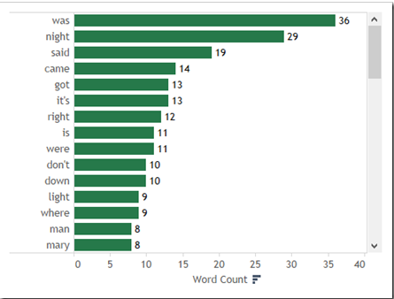
Using Word Clouds, a Bar Chart gives a typical gauge and consequently makes looking at the information considerably less demanding. Moreover the sort arrange guides for the business through the view. It is easy for the business to analyze the tests using the SEO words
Recommendations to business
The guidance for utilizing this program is that it is imperative to take time to tidy up the information before bringing in it into the word cloud generator. For instance, talk with transcripts, may have regular conversational fillers, for example, "you know" or "like" that should be evacuated. Guarantee that the information gathering group records catchphrases consistently– with steady upper casing – since some product bundles won't perceive promoted and uncapitalized words as the same.
Word clouds are a simple to utilize and economical choice for imagining Text information. One of the difficulties of deciphering word cloud is that the show underscores recurrence of words, not really their significance. Word cloud won't precisely mirror the substance of Text if somewhat unique words are utilized for a similar thought (for instance, 'vast', 'immense', 'monster', 'huge', and 'huge'). They likewise don't give setting, so the significance of individual words might be lost. As a result of these impediments, word cloud are most appropriate for exploratory subjective examination.

References
Digital business in the digital age. (n.d.). Books on Demand.
Havaldar, K. K. (2014). Business marketing: Text and cases. New Dehi: Tata McGraw Hill.
In Gillaerts, P., & In Gotti, M. (2008). Genre variation in business letters. Bern: P. Lang.
Kornetzki, A. (2012). Contrastive analysis of news text types in Russian, British and American business online and print media.

